Political Science 3044

Foundations of American Democracy
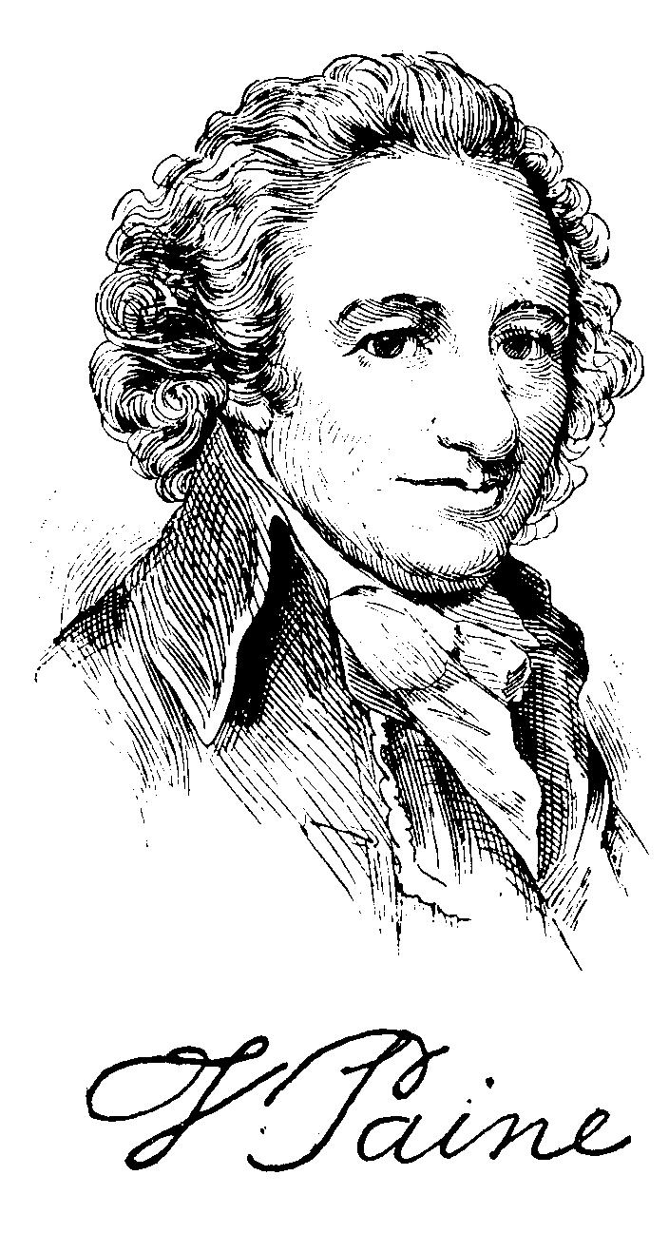
Spring Semester, 2013

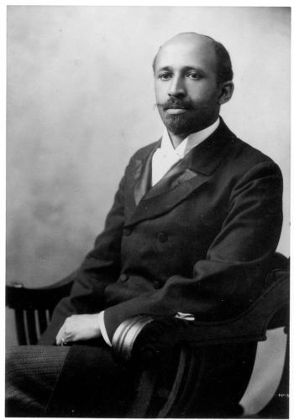
Mon. & Wed., 10-11:30
Seigle 106

Professor Hayward
chayward@wustl.edu
Office hrs: Tues., 3-4
Seigle 232

TA: Benjaimn Bricker
bbricker@wustl.edu
Office hrs: Wed., 2-3
Seigle 276

Since its founding, the United States of America has been strongly identified with principles of democratic rule. This course provides an introduction to some philosophical and historical foundations of American democracy. Over the course of the semester, we will ask what democracy means, and what it requires. We will examine thinking about political rights and liberty at the American founding. We will ask what democratic inclusion and political equality entail. We will ask what democracy means, and what it should mean, in the American context, and whether and to what extent American institutions embody democratic ideals.
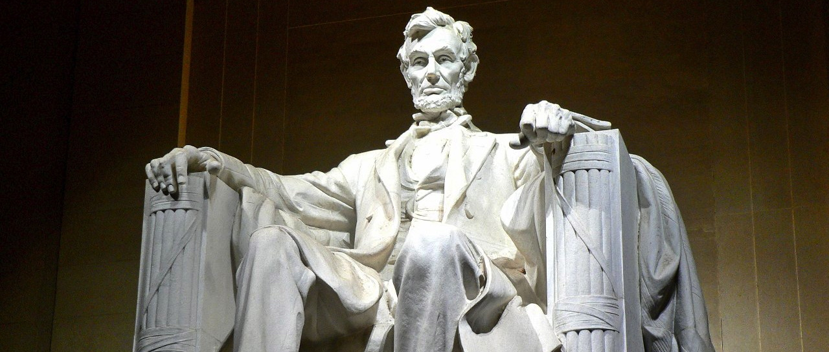
Course Requirements

1. You must complete the readings in a timely fashion and participate actively in class discussions. Please note that, although the readings average fewer than 50 pages per class, they are often dense and difficult, requiring careful attention. Class participation counts for ten percent of your grade.

2. You will also complete weekly writing assignments and post them to the class Blackboard site. These consist in two parts, which will be graded as a whole. Your top nine weekly grades count for 90 percent of your grade.

The first part of your weekly assignment is to write a response paper, which should be clear, concise, and thoughtful. It should be one single-spaced page (normal font, normal margins), and it must be posted to the class Blackboard site no later than 5 p.m. the evening before we meet. Half of the class will write papers for our Monday meetings, the other half for our Wednesday meetings. (You will have a chance to let me know your preference at our first meeting, and I will do my best to accommodate it).

2a. Your paper should accomplish two things. First, you should summarize one of the most important claims advanced by the thinker whose work we are reading. You should paraphrase this claim, and also explain how the author advanced and supported it, and why you think it is important.

2b. Second, you should respond to this claim, for example by endorsing or critiquing it, comparing it to an important claim advanced by another thinker whose work we have read, or applying it to some political issue that interests you. (You might begin this second part of your paper in one of the following ways: “I agree, because...”“I disagree, because...” “I was surprised by...” “I was struck by the difference between this view and...” “I was struck by the similarity between this view and...”“If we apply this view to...”)

Please create a thread under the relevant forum, put your own name and the name of the author whose work you are responding to in the subject line (e.g., “Tom Smith on Thomas Paine”), cut and paste your paper into the “message” section, and click “submit.”

You will have the opportunity to write a total of thirteen (Monday) or fourteen (Wednesday) response papers. This means you may “take a bye” several weeks during the semester, without having to give an excuse or advance notice. However, late papers will not count toward your nine.

3. The second part of your weekly assignment is to be completed in advance of the class meeting when you are not required to write a response paper. Your task is to post at least one, and up to three, responses to the response papers written by your classmates. Again, these should be clear, concise, and thoughtful. A single paragraph will do.

Your response to the response must be posted to the class Blackboard site no later than 11 p.m. the evening before we meet. Please respond to papers that have not yet received responses at the time when you post, unless at that time every response paper has received at least one student response. In your paragraph, you should carefully engage what the other student has written. (You might begin: “This response paper made me think...”“I agree with [classmate], because...”“I disagree with [classmate], because...”“I think [the philosopher / author of the course text] might reply to [classmate] by saying...”).

Please create a thread under the relevant forum, put your own name and the name of the student whose paper you are responding to in the subject line (e.g., “Mary Jones response to Tom Smith”), cut and paste your comment into the “message” section, and click “submit.”

Again, you will have the opportunity to write a total of thirteen (Monday) or fourteen (Wednesday) response-to-response papers, so you may “take a bye” several times during the semester, and again, late papers will not count toward your nine.

Course Materials

1. Readings marked [E] are available for download and printing from Blackboard. You
should print out the files, mark them up, and bring them to class with you. We will
frequently refer to the readings during class meetings.

2. An electronic copy of this syllabus and important announcements are also available from
Blackboard.

3. Readings marked [B] are books you will need to secure. They are listed below in the
order in which we will read them. Please note: although these books are on sale at the
campus bookstore, bookstores rarely stock enough copies of course texts. So please do
not wait to purchase them, and then assume they will be there the week before you need
them. Look for them well in advance and, if you can’t find them, go to another book store
or order them online.

Alexis de Tocqueville, Democracy in America, ed. J.P. Mayer, transl. George Lawrence
(New York: Harpercollins Perennial Classics, 2000).

W.E.B. DuBois, The Souls of Black Folk, Oxford World Classics Edition (Oxford, UK: Oxford
University Press, 2009)

Course Syllabus and Schedule of Class Meetings

Monday January 14: Introduction and course overview (no readings)

I. Foundations: What is American Political Thought?
What is Democracy?

Wednesday, January 16: Robert G. McCloskey, “American Political Thought and the Study
of Politics” (1957) [E]

Martin Diamond, “American Political Thought and the Study
of Politics: Comment on McCloskey” (1957) [E]

Monday, January 21: Martin Luther King Day (No class).

Wednesday, January 23: Robert Dahl, Democracy and Its Critics, chs. 6 and 7 (1989) [E]

Monday, January 28: Robert Dahl, Democracy and Its Critics, chs. 8 and 9 (1989) [E]

Wednesday, January 30: Jon Elster, “The Market and the Forum” (1989) [E]

II. Democracy and Liberty: The American Revolution and Founding

Monday, February 4: Thomas Paine, Common Sense (1776) [E]

Wednesday, February 6: Thomas Jefferson, “Declaration of Independence” (1776); Notes on the State of Virginia, Queries 8, 11, 13, 14, 17-19, and 22 (1785); and letters to Madison October 28, 1785 and January 30, 1787 [E]

Monday, February 11: The Federalist Papers, numbers 10 (1787) and 51 (1788) and the Constitution of the United States of America (1789) [E]

Wednesday, February 13: The Federal Farmer, Letters I-V (1787) and Essays of Brutus I-III (1787) [E]

Monday, February 18: Herbert Storing, What the Anti-Federalists Were For (1981), Introduction and Chapter 3 [E]

Wednesday, February 20: In-class debate: “The Federalists may have won, but they were wrong.” (No new readings).

III. Democracy in America

Monday, February 25: Alexis de Tocqueville, Democracy in America, Author’s
Introduction, pp. 9-20; Vol. 1, Part I, chs. 2-(part of) 5, pp. 31-70 (1835) [B]

Wednesday, Februrary 27: Tocqueville, Democracy in America, Vol. 1, Part I, chs. (part of) 5, pp. 87-98; Vol. 1, Part II, chs. 3- (part of 5), pp. 180-199; chs. 6-7, pp. 231-261 (1835) [B]

Monday, March 4: Tocqueville, Democracy in America, Vol. 1, Part II, chs. 8-9 (pp.
262-315 (1835) [B]

Wednesday, March 6: Tocqueville, Democracy in America, Vol. 1, Part II, chs 10, pp.
316-363; Vol 2, Part II, chs. 9-10 (pp. 590-594) and ch. 12 (pp.
600-603). (** excerpts changed, need new scans)

IV. Democracy and (In)Equality

Monday, March 18: Dred Scott v. Sandford (1856) [E]

Wednesday, March 20: Lincoln’s “House Divided” Speech (1858) [E]

Lincoln-Douglas Debates, no. 1; no. 4, pp. 131-132 only; and no. 7 (1858) [E]

Lincoln’s First Inaugural Address (1861) [E]

Address on Colonization to a Delegation of Black Americans
(1862) [E]

The Emancipation Proclamation (1863) [E]

The Gettysburg Address (1863) [E]

Monday, March 25: W.E.B. DuBois, The Souls of Black Folk, “The Forethought”; I,
“Of Our Spiritual Strivings”; IV, “Of the Meaning of Progress”;
and V, “Of the Wings of Atalanta” (1903) [B]

Wednesday, March 27: W.E.B. DuBois, The Souls of Black Folk, IX, “Of the Sons of
Master and Man”; X, “Of the Faith of the Fathers”; XIV, “The
Sorrow Songs,” and “The After-Thought” (1903) [B]

Monday, April 1: “Seneca Falls Declaration” (1848) [E]
Sojourner Truth, “Ain’t I a Woman?” (1851) [E]

J.S. Mill, The Subjection of Women, chs. 1-2 (1869) [E]

Wednesday, April 3: J.S. Mill, The Subjection of Women, chs. 3-4 (1869) [E]
Guest lecturer: Benjamin Bricker

Monday, April 8: William Graham Sumner, What the Social Classes Owe to Each
Other, Introduction and chs. I-V (1883) [E]

Wednesday, April 10: William Graham Sumner, What the Social Classes Owe to Each
Other, chs. VI-XI (1883) [E]

V. What does it Mean to be an American?

Monday, April 15: John F. Kennedy Inaugural Address (1961); Martin Luther King,
Jr., “Letter from a Birmingham Jail” (1963); Malcolm X, “The
Ballet or the Bullet,” (1964) [E]

Wednesday, April 17: Barry Goldwater, “Acceptance Speech” (1964); Lyndon Johnson,
“Commencement Address at Howard University: ‘To Fulfill these
Rights’” (1965); Lyndon Johnson, “State of the Union Address”
(“War on Poverty” speech) (1964) [E]

Monday, April 22: Michael Walzer, “What Does It Mean to be an American?” [2004]
[E]

Wednesday, April 24: Robert Dahl, “On Removing Certain Impediments to Democracy
in the United States” (1977) [E]

Rogers Smith, Civic Ideals: Conflicting Visions of Citizenship in
U.S. History, Introduction and ch. 1 (1997) [E]

